

A RESEARCH WORK REPORT ON
“Air Quality Index Prediction using Machine Learning Models”

Developed by
Dhruv Bhujbal
Prathmesh Pawar

in partial fulfillment of

M.Sc. (Data Science) Sem-IV
Under

Savitribai Phule Pune University 2025- 2026



CERTIFICATE
Exam Seat No.:______

This is to certify that Dhruv Bhujbal (01) has successfully completed the Research Work entitled ____________________________________________
for M.Sc.(Data Science) Sem-IV of Savitribai Phule Pune University for the Academic Year 2025-26.

Project Guide Coordinator H.O.D & In-charge Principal (CS)

External Examiner: Internal Examiner:



CERTIFICATE
Exam Seat No.:______

This is to certify that Prathmesh Pawar (43) has successfully completed the Research Work entitled ____________________________________________
for M.Sc.(Data Science) Sem-IV of Savitribai Phule Pune University for the Academic Year 2025-26.

Project Guide Coordinator H.O.D & In-charge Principal (CS)

External Examiner: Internal Examiner:

Acknowledgement

I would like to express my sincere gratitude to all those who have contributed to the successful completion of this project. It has been my sincere effort to present the subject in a simple and clear manner, and I am truly appreciative of the guidance and support provided by everyone involved.
First and foremost, I would like to extend my heartfelt thanks to my project guide, Mrs. Sonali Namade, for their valuable guidance and constant support throughout the project. Their insights and expertise have been instrumental in the development of this work.
I am also deeply grateful to Dr. Ranjit Patil, Principal of the College, for their unwavering support and encouragement, which motivated me throughout the course of this project. Special thanks to Dr. Sonali Nemade, Coordinator of the Department, for her continuous assistance and guidance.
Working on this project has been an incredibly enriching and enlightening experience. I have learned that "team spirit makes even the most difficult tasks easier and more enjoyable." I would like to thank my friends for their cooperation, keen interest, and valuable suggestions that contributed to the success of this project.
Once again, my heartfelt thanks to everyone who supported me in this endeavour.

INDEX

Sr.No | Topic
1. | Title Of Research
2. | Certificate
3. | Published Research Paper Certificate
4. | List of Figures
5. | List of Tables
6. | Introduction
7. | Problem Statement
8. | Objective
9. | Literature Review of the previous  Research in the area.
10. | Data Collection
11. | Actual Work Done with Experimental  Setup
12. | Results
13. | Future Scope of Research
14. | Limitation of research
15. | Bibliography
16. | References

Title of Research Paper

“Air Quality Index Prediction using Machine Learning Models”

4. List of Figures
- Figure 1: (System Architecture of AQI Prediction Model)
Figure 1 illustrates the complete end-to-end architecture of the Air Quality Index (AQI) prediction system, showing how raw environmental data is transformed into real-time predictions through a machine learning pipeline and deployed web application.

The workflow begins with the Indian Weather Dataset obtained from Kaggle, which acts as the primary historical data source. This dataset contains multiple meteorological attributes required for AQI prediction. The data is first processed using the Pandas library, which is responsible for loading, organizing, and manipulating structured datasets efficiently.

A crucial stage in the pipeline is Data Preprocessing and Cleaning, where the dataset undergoes several preparation steps to improve model accuracy and reliability. These include:

- Handling missing or null values
- Removing duplicate records
- Formatting inconsistent data entries
- Selecting relevant environmental features
- Preparing structured input variables for machine learning

After preprocessing, the cleaned dataset is passed into Scikit-learn, a machine learning framework used for model development and evaluation. The system employs the Random Forest Regressor, a powerful ensemble learning algorithm capable of capturing nonlinear relationships between weather variables and AQI levels. This algorithm improves prediction stability by combining multiple decision trees.

Once training is completed, the optimized model is saved using Joblib serialization as best_aqi_model.pkl. Saving the model allows reuse during deployment without retraining, improving efficiency and reducing computational cost.

The trained model is then integrated into a Streamlit Web Application, which serves as the user interface. The application interacts with external services and users simultaneously by:

- Loading the saved machine learning model
- Fetching live environmental data through a Weather API
- Processing user requests dynamically

The deployed system supports three prediction modes:

- Mode 1: Historical Forecast – Predicts AQI using past datasets.
- Mode 2: Scenario Simulation – Allows users to test hypothetical environmental conditions.
- Mode 3: Live Real-Time Prediction – Generates predictions using real-time weather data.

Overall, the architecture demonstrates a complete machine learning lifecycle, beginning from data acquisition and preprocessing, progressing through model training and storage, and ending with an interactive real-world deployment capable of delivering intelligent AQI predictions.

Figure 2: Prediction Workflow Decision Flowchart
Figure 2 represents the operational workflow executed inside the application after user interaction. It explains how the system dynamically selects data sources and processes inputs before generating AQI predictions.
The workflow begins with User Selection, where the user interacts with the application interface and chooses a prediction mode. The user then provides required environmental inputs, which move into a decision stage labeled “Is it Live Mode?”. This decision node determines how the system gathers prediction data.
The execution flow splits into two possible paths:
1. Live Mode (Yes Path)
If live prediction is selected:
- The system sends requests to a Weather API.
- Real-time weather parameters are fetched automatically.
- Current atmospheric conditions are collected without manual input.
2. Historical/User Input Mode (No Path)
If live mode is not selected:
- The system extracts historical values or manually entered user data.
- Stored datasets or simulated parameters are used as prediction inputs.
Although the data sources differ, both paths merge into a common processing stage where environmental parameters are standardized. At this stage:
- Six weather-related features are formatted.
- Data structure is aligned with the trained model requirements.
- Inputs are validated before prediction.
The formatted data is then passed into the Machine Learning Model, where the Random Forest algorithm performs computation and AQI estimation. After calculations are completed, the application proceeds to the final stage:
- Prediction results are generated.
- AQI values and related insights are displayed to the user through the interface.
This flowchart highlights how the system maintains flexibility by supporting both live and historical prediction workflows while ensuring consistent preprocessing and model execution. It demonstrates an efficient decision-driven pipeline that connects user interaction, API integration, machine learning inference, and result visualization into a seamless prediction process.
Figure 3: PM2.5 Target Variable Distribution
Figure 3 presents the distribution of the PM2.5 target variable across different pollution concentration categories. The chart visualizes how frequently various air quality levels occur within the dataset, helping understand data balance and environmental trends.
The horizontal axis represents PM2.5 concentration bins (µg/m³) categorized into pollution severity levels:
- 0–50 (Good)
- 51–100 (Moderate)
- 101–200 (Poor)
- 201–300 (Bad)
- 300+ (Severe)
The vertical axis indicates the number of records, showing how many observations fall into each category.
The visualization reveals several important characteristics:
- The Good category (0–50) contains the highest number of records, indicating that cleaner air conditions appear frequently in the dataset.
- The Moderate range (51–100) also shows a large concentration, suggesting transitional pollution levels are common.
- Record counts gradually decrease as pollution severity increases.
- The Severe category (300+) has the fewest samples, meaning extreme pollution events are relatively rare.
This uneven distribution indicates a class imbalance, where lower pollution levels dominate the dataset compared to highly polluted conditions.
From a machine learning perspective, this distribution is significant because:
- Models may learn better patterns for common AQI ranges.
- Rare extreme pollution cases may require special handling.
- Evaluation metrics must consider imbalance effects.
Overall, the figure provides insight into environmental patterns and dataset characteristics, helping justify preprocessing decisions and model selection strategies used in AQI prediction.
Figure 4: Model Accuracy (R-Squared %) Comparison
Figure 4 compares the predictive performance of two machine learning models using the R-Squared (R²) metric, which measures how much variance in AQI values is explained by each model.
The chart compares:
- Linear Regression (Baseline Model)
- Random Forest (Proposed Model)
The vertical axis represents variance explained (%), indicating prediction accuracy.
Key observations from the chart include:
- Linear Regression achieves approximately 38% variance explanation, indicating limited ability to capture complex environmental relationships.
- Random Forest achieves around 52% variance explanation, demonstrating significantly improved predictive performance.
- The improvement confirms that AQI prediction involves nonlinear interactions between variables such as temperature, humidity, and pollutants.
The comparison highlights important conclusions:
- Linear Regression assumes linear relationships, which may oversimplify environmental dynamics.
- Random Forest combines multiple decision trees, enabling better handling of nonlinear patterns and feature interactions.
- Ensemble learning methods are more suitable for environmental prediction problems.
This figure validates the selection of Random Forest as the final deployed model in the system architecture. The improved R² score indicates stronger generalization capability and more reliable AQI predictions when compared with the baseline approach.
Figure 5: AQI Prediction Engine – System Home Interface
Figure 5 presents the main dashboard interface of the AQI Prediction Engine application. This screen acts as the entry point of the system where users obtain an overview of the air quality forecasting platform. The interface introduces the objective of the project, displays dataset statistics, and confirms successful system initialization.
Key Components
- Navigation panel containing application modules:
  - Home (Abstract)
  - Monthly Forecast
  - Scenario Simulation
  - Live Prediction
  - Data Dashboard
  - Model Methodology
- Research abstract explaining meteorological AQI prediction.
- Dataset loading confirmation message.
- Global dataset average statistics including:
  - Mean PM2.5 concentration
  - Mean PM10 concentration
  - Average temperature.
Explanation
The home interface serves as the informational and operational starting point of the AQI prediction system. It summarizes the research objective, which focuses on predicting air pollution using meteorological factors rather than traditional emission inventories. The dashboard verifies system readiness by indicating successful loading of training records, ensuring reliability before prediction tasks begin. Additionally, global dataset averages provide contextual insight into pollution trends derived from historical data, helping users understand baseline environmental conditions. The structured navigation panel allows seamless movement across prediction modes and analytical tools, enhancing usability and workflow efficiency.

Figure 6: Mode 1 – Historical Monthly Forecasting Interface
Figure 6 illustrates the Historical Monthly Forecasting module, where users predict average PM2.5 levels for a selected city and month based on historical weather patterns.
Key Components
- City selection dropdown.
- Month selection control.
- Prediction execution button.
- Displayed predicted PM2.5 value.
- Model explanation section showing contributing weather factors:
  - Average temperature
  - Average wind speed
  - Rainfall levels.
Explanation
This module enables retrospective air quality prediction using historical meteorological averages. After selecting a city and month, the trained machine learning model estimates expected pollution levels. The system also provides interpretability by displaying environmental parameters influencing the prediction. This transparency helps users understand how atmospheric conditions such as temperature and wind dispersion impact pollution accumulation. The feature is particularly useful for seasonal analysis and long-term environmental planning.
Figure 7: Mode 3 – Real-Time AQI Prediction Interface
Figure 3 shows the real-time prediction functionality that integrates live weather data with the trained machine learning model.
Key Components
- City input field.
- Live data retrieval button.
- API data confirmation message.
- Model vs. Reality comparison panel.
- Current weather conditions display:
  - Temperature
  - Wind speed
  - Humidity
  - Visibility.
Explanation
The real-time prediction interface demonstrates dynamic AQI forecasting using live meteorological inputs fetched through a weather API. Once data is retrieved, the model generates a PM2.5 prediction and compares it against actual sensor measurements. This comparison helps evaluate model accuracy and performance in real-world conditions. By presenting environmental variables alongside predictions, the system provides insight into how changing atmospheric conditions influence pollution levels, making the application suitable for monitoring and decision-making.
Figure 8: Analytical Dashboard – Pollution Insights Visualization
Figure 8 displays the analytical dashboard used for exploratory data analysis and visualization of pollution trends.
Key Components
- Bar chart visualization.
- Top 10 cities ranked by average PM2.5 levels.
- Color gradient representing pollution intensity.
- Comparative city-based pollution distribution.
Explanation
The analytical dashboard provides visual understanding of pollution distribution across major cities. The bar chart highlights regions with the highest particulate matter concentration, allowing quick identification of pollution hotspots. Color intensity further enhances interpretation by visually encoding severity levels. This module supports research analysis by revealing geographical pollution patterns and assisting policymakers or researchers in identifying high-risk areas.

Figure 9: Methodology Visualization Page
Figure 9 represents the methodology analysis interface containing advanced visual analytics related to feature relationships and atmospheric effects.
Key Components
- Wind dispersion impact visualization.
- Scatter and distribution analysis.
- Feature correlation heatmap.
- Relationship mapping between meteorological parameters.
Explanation
This page explains how environmental variables interact to influence AQI prediction. The visualization demonstrates how wind speed affects pollutant dispersion and how correlations exist between atmospheric parameters such as humidity, pressure, and temperature. The heatmap provides statistical relationships among features used during model training. Such analysis validates feature selection and supports scientific reasoning behind the machine learning approach.
Figure 10: Model Methodology & Evaluation Page
Figure 10 presents the complete methodology and evaluation documentation interface of the AQI prediction system.
Key Components
- Target leakage prevention explanation.
- Model architecture description.
- Performance metrics display.
- Feature importance visualization chart.
Explanation
This interface documents the internal design and evaluation process of the machine learning model. It explains how data leakage was prevented to maintain prediction reliability. Model performance metrics quantify prediction accuracy using statistical evaluation measures. The feature importance chart provides explainable AI insights by ranking meteorological variables based on their influence on predictions. This page ensures transparency, reproducibility, and scientific validation of the implemented system.

5. List of Tables
Table 1: Meteorological Features Selected for PM2.5 Prediction
Table 1 lists the environmental variables used as input features for AQI prediction.
The selected meteorological parameters represent atmospheric conditions that directly influence pollutant formation and dispersion. Temperature affects chemical reactions in the atmosphere, wind speed controls pollutant spread, humidity impacts particle aggregation, pressure influences air stagnation, precipitation removes pollutants through wet deposition, and visibility acts as an indirect indicator of particulate concentration. Together, these features provide a comprehensive environmental representation enabling accurate machine learning predictions.
Table 2: Model Performance and Error Metrics
Table 2 compares performance results between baseline Linear Regression and the proposed Random Forest model.
Evaluation metrics demonstrate that the Random Forest model significantly improves prediction accuracy compared to the baseline model. Higher R-squared values indicate better variance explanation, while lower RMSE and MAE values show reduced prediction errors. These results validate the selection of ensemble learning for handling nonlinear meteorological relationships affecting air quality.
Table 3: Sample Real-Time Data Payload (Weather API Extraction)
Table 3 shows a sample dataset retrieved from the Weather API used during real-time prediction.
The table illustrates how live environmental data is structured before being fed into the trained model. Each parameter corresponds to atmospheric measurements such as temperature, humidity, wind speed, and pressure. Proper formatting ensures compatibility with the trained machine learning pipeline, allowing seamless integration between external APIs and predictive analytics.

6. Introduction
In the digital age, information spreads faster than ever before. Social media platforms, online news portals, and instant messaging apps allow people to access news from around the world in seconds. While this has made information more accessible, it has also created fertile ground for the rapid dissemination of fake news. Fake news is intentionally false or misleading information that is presented as legitimate news, often with the aim of manipulating public opinion, promoting political agendas, or generating profit through sensationalism.
The rise of fake news poses significant challenges to society. It can mislead citizens, create widespread panic, influence elections, and even affect financial markets. Traditional methods of verifying news, such as manual fact-checking, are time-consuming and often insufficient given the sheer volume of content published online daily. Consequently, there is an urgent need for automated, reliable, and scalable methods to detect fake news in real-time.
Artificial Intelligence (AI) and Machine Learning (ML) have emerged as powerful tools to address this problem. In particular, Natural Language Processing (NLP) techniques enable computers to understand, interpret, and analyse human language, making them ideal for tasks such as text classification, sentiment analysis, and spam detection. Over the past few years, transformer-based models like BERT, Distil BERT, Roberta, and GPT have revolutionized NLP by priding pre-trained models capable of understanding complex contextual relationships in text.
This project focuses on building a robust fake news detection system using Distil BERT, a lighter and faster variant of BERT. The model is fine-tuned on a curated dataset of real and fake news articles to classify news accurately. Combining the news title and content as input provides a richer context for the model, allowing it to capture subtle cues that differentiate real news from fake.
The project consists of several key components:
- Data Collection and Pre-processing: Curating a high-quality dataset of news articles, cleaning the text, and combining the title and content to form a complete context.
- Tokenization and Feature Extraction: Converting raw text into numerical representations suitable for transformer models.
- Model Training and Fine-Tuning: Fine-tuning DistilBERT on the dataset for binary classification (REAL vs FAKE) and optimizing hyperparameters to achieve high accuracy.
- Evaluation and Metrics: Measuring model performance using accuracy, precision, recall, F1-score, and confusion matrices.
- Web-based Deployment: Integrating the model into a Flask web application, providing users with a simple interface to input news articles and receive real-time predictions. The system also displays confidence scores, keeps a prediction history, and highlights trending fake news.
Motivation behind the project:
- The rapid spread of misinformation can have far-reaching consequences, including influencing public opinion and promoting false narratives.
- Automated detection tools can assist individuals, journalists, and organizations in identifying unreliable information quickly and efficiently.
- Implementing state-of-the-art NLP techniques on practical applications strengthens the understanding of machine learning concepts and real-world deployment challenges.
Significance of the project:
- Provides a practical solution to mitigate the impact of fake news in digital media.
- Demonstrates the capabilities of transformer-based NLP models for text classification tasks.
- Offers a user-friendly interface that can be used by non-technical users to verify news credibility.
- Lays the groundwork for future research in automated fake news detection, multilingual news classification, and integration with fact-checking platforms.
By combining advanced machine learning techniques, carefully curated datasets, and an interactive web interface, this project aims to provide a comprehensive fake news detection system that is both accurate and accessible. It bridges the gap between academic research in NLP and practical applications that address real-world societal challenges.

7.Problem Statement
2.1 The Issue of Target Leakage in Existing Literature
A critical review of recent literature on Air Quality Index (AQI) prediction reveals a pervasive methodological flaw: the inclusion of highly correlated, auto-regressive features. Many researchers train models to predict the overall AQI (such as the US-EPA index) by providing the model with real-time PM2.5, PM10, and Carbon Monoxide levels. Because the AQI is mathematically derived directly from these exact pollutants, the machine learning models artificially achieve near-perfect accuracy (R² ≈ 1.0). This is known as "target leakage." While these models look impressive on paper, they are entirely useless for practical forecasting; if a meteorologist already has the PM2.5 levels, they do not need an AI to tell them the AQI—they can simply use a calculator.
2.2 The Lack of Interactive Deployment
Furthermore, most predictive environmental models remain confined to static research papers or Jupyter Notebooks. There is a distinct lack of deployed, user-facing applications that allow policymakers, researchers, or the public to interact with the data.
2.3 Formal Problem Statement
Therefore, the core problem addressed by this research is twofold:
- There is a critical need to develop a scientifically valid predictive model for PM2.5 that relies exclusively on exogenous meteorological variables, eliminating target leakage and ensuring real-world forecasting utility.
- There is a necessity to transition this predictive model from a static academic exercise into a live, interactive Explainable AI (XAI) web application capable of historical analysis, scenario simulation, and real-time validation.

8. Objective
The overarching aim of this research is to bridge the gap between theoretical atmospheric science and applied machine learning by engineering a robust, interactive, and purely meteorological-based predictive model for fine particulate matter (PM2.5). To systematically address the gaps identified in the problem statement, this study is driven by four specific, interconnected objectives, categorized into methodological, analytical, and deployment goals.
3.1 Primary Objective: Development of an Exogenous Meteorological Predictive Model
The central objective of this research is to design, train, and evaluate a machine learning model capable of accurately forecasting PM2.5 concentrations utilizing only exogenous meteorological variables. Unlike traditional models that rely on the presence of existing pollutants to forecast future air quality, this project aims to isolate the physical relationship between atmospheric conditions and particulate accumulation. By restricting the feature space strictly to Temperature, Wind Speed, Humidity, Atmospheric Pressure, Precipitation, and Visibility, the objective is to prove that standard weather forecasts can be successfully repurposed as early-warning systems for severe pollution events, particularly in geographies where physical IoT air quality sensors are unavailable.
3.2 Methodological Objective: Eradication of Target Leakage
A critical secondary objective is to establish a rigorous data preprocessing protocol that actively identifies and mitigates "target leakage"—a widespread methodological fallacy in contemporary environmental data science. Many existing models achieve artificially inflated accuracy metrics (R-Squared values approaching 1.0) by inadvertently including endogenous variables, such as PM10, Carbon Monoxide, or pre-calculated Air Quality Indices (AQI), as predictors for PM2.5. Therefore, the objective here is to demonstrate a strict feature-isolation pipeline that mathematically prevents the model from utilizing dependent pollution metrics, ensuring that the resulting algorithm possesses genuine, real-world predictive validity rather than merely memorizing mathematical derivatives.
3.3 Analytical Objective: Quantifying Variance and Feature Importance (Explainable AI)
In the realm of environmental policy, "black-box" AI models are often rejected by stakeholders because they do not explain why a prediction was made. Thus, the third objective is to utilize an Explainable AI (XAI) architecture—specifically a Random Forest Regressor—to extract and quantify the internal decision-making weights of the model.
- Variance Quantification: The research aims to mathematically quantify the exact percentage of PM2.5 variance that is governed strictly by the weather, establishing a firm statistical baseline (the R-Squared metric).
- Feature Importance: The objective is to extract the "Gini Importance" or feature weights from the ensemble model to definitively rank which atmospheric conditions (e.g., Wind Dispersion vs. Wet Deposition via rain) have the highest mathematical impact on mitigating PM2.5 smog.
3.4 Deployment Objective: Engineering an Interactive Forecasting Dashboard
The final, and highly practical, objective is to transition the machine learning model out of a static, offline development environment (e.g., Jupyter Notebooks) and deploy it as a production-ready Software as a Service (SaaS) application. The goal is to architect a high-performance web interface using the Streamlit framework that allows end-users to interact with the trained model without requiring programming expertise. This deployment objective is further subdivided into three functional requirements:
- Historical Forecasting: To allow users to query the model using temporal aggregations (City and Month) to generate expected baseline pollution metrics based on historical weather patterns.
- Scenario Simulation: To provide a parameterized user interface (UI) where environmental researchers can manually adjust hypothetical weather variables (e.g., simulating a sudden drop in wind speed) and observe the resulting predicted PM2.5 accumulation in real-time.
- Live API Validation: To engineer a backend integration with a live meteorological data provider (WeatherAPI) via RESTful HTTP requests, enabling the model to ingest real-time weather data and validate its predictions dynamically against physical, real-world sensor outputs.

9. Literature Review of Previous Research
A rigorous review of existing academic literature is essential for establishing the theoretical foundation of this research and identifying the existing gaps in environmental forecasting methodologies. The development of this purely meteorological PM2.5 prediction system was heavily informed by the successes and limitations of the last decade of published research. This chapter analyzes 10 pivotal research papers and thematic studies, detailing the specific methodologies, algorithms, and atmospheric physics adopted for this project.
4.1 Foundational Algorithms and Meteorological Physics
1. Breiman, L. (2001). "Random Forests" (Machine Learning)
- Summary: This is the foundational mathematical paper that introduced the Random Forest algorithm, proving how bootstrap aggregating (bagging) multiple decision trees reduces variance and prevents overfitting on complex datasets.
- What We Used: This paper provided the mathematical justification for selecting Random Forest over standard decision trees. We adopted the n_estimators hyperparameter logic to build our 100-tree ensemble, ensuring our model remained robust against extreme winter pollution outliers.
2. Tai, A. P. K., et al. (2010). "Correlations between fine particulate matter and meteorological variables" (Atmospheric Environment)
- Summary: This study conducted a massive statistical analysis across the United States, proving that daily variations in PM2.5 are highly correlated with temperature, wind speed, and relative humidity.
- What We Used: This paper served as our blueprint for Feature Selection. We explicitly adopted their findings to define our 1x6 input tensor (Temperature, Wind, Humidity, Pressure, Precipitation, Visibility), knowing these variables had proven, peer-reviewed mathematical relationships with aerosol mass.
3. Barmpadimos, I., et al. (2011). "Influence of meteorology on PM trends" (Atmospheric Chemistry and Physics)
- Summary: This research explored the non-linear "wash-out" effect of rain (wet deposition) and how stagnant atmospheric pressure traps particulate matter.
- What We Used: We learned that meteorological relationships are non-linear (e.g., rain doesn't just lower PM2.5 slightly; it drops it sharply). This directly informed our decision to reject Multiple Linear Regression as our primary model, as linear hyperplanes cannot map sudden atmospheric threshold events.
4.2 The "Target Leakage" Problem in Recent ML Studies
4. Chen, Z., et al. (2020). "Influence of meteorological conditions on PM2.5 concentrations: A review" (Environment International)
- Summary: Chen's extensive review of Chinese air quality models revealed a systemic flaw in modern ML research: many highly accurate models use secondary pollutants (like PM10, CO, or Ozone) as input features to predict PM2.5.
- What We Used: This paper highlighted the exact Gap in Research our project solves: Target Leakage. We adopted their critique to justify aggressively sanitizing our Kaggle dataset, strictly dropping all endogenous chemical pollutants from our training matrix to create a pure "meteorological vacuum."
5. Zheng, Y., et al. (2015). "Forecasting fine-grained air quality based on big data" (KDD Proceedings)
- Summary: This paper demonstrated how to fuse heterogeneous data sources (weather, traffic, spatial data) to predict air quality, achieving high accuracy but resulting in a highly localized, overly complex "black box" model.
- What We Used: We learned the danger of "over-engineering" a model. We chose to do the exact opposite: we stripped our model down to purely exogenous weather features to ensure it remained lightweight, generalized, and capable of running on low-resource hardware (CPU instead of GPU).
4.3 Explainable AI (XAI) and Optical Visibility
6. Lundberg, S. M., & Lee, S.-I. (2017). "A Unified Approach to Interpreting Model Predictions" (NeurIPS)
- Summary: This paper revolutionized Explainable AI (XAI) by introducing SHAP values and formalizing how tree-based models calculate Gini feature importance.
- What We Used: We adopted this XAI framework for our Methodology page. Instead of presenting a "black box" prediction, we extracted the feature_importances_ weights from our Random Forest, allowing us to mathematically prove to the user exactly which weather conditions were driving the pollution spike.
7. Singh, A., et al. (2017). "Aerosol optical depth and visibility associations" (Journal of Environmental Sciences)
- Summary: This physics paper proved the inverse optical relationship between suspended fine particulate matter and atmospheric visibility ranges.
- What We Used: When our XAI feature importance results showed "Visibility" holding a massive 34% predictive weight, we utilized the physics from this paper to scientifically validate our model's logic: PM2.5 physically scatters visible light, making visibility the strongest mathematical proxy for pollution density.
4.4 Deployment, UI/UX, and Real-Time Systems
8. McKinney, W. (2010). "Data Structures for Statistical Computing in Python" (SciPy)
- Summary: The foundational documentation for the Pandas library, detailing how to efficiently handle time-series environmental telemetry using DataFrames.
- What We Used: We utilized the temporal string-parsing techniques outlined here to extract the Month feature from the raw DateTime objects, which directly enabled the creation of "Mode 1: Historical Forecasting" in our web application.

9. Streamlit & Plotly Architectural Case Studies (Recent Industry Papers, 2021-2023)
- Summary: Recent software engineering case studies have highlighted the shift from static Jupyter Notebooks to reactive, Python-native web frameworks for deploying data science applications.
- What We Used: This informed our entire frontend architecture. We abandoned traditional HTML/JS/Flask routing in favor of Streamlit and Plotly, enabling us to build the highly interactive "Mode 2: Scenario Simulation" with live slider widgets that bind directly to our serialized .pkl model.
10. REST API Integration in Smart City Frameworks (Various IEEE Papers)
- Summary: Smart City infrastructure relies on stateless RESTful HTTP requests to connect offline predictive models with live IoT physical sensors.
- What We Used: This research governed the engineering of "Mode 3: Live API Validation." We adopted the standard JSON payload parsing architecture to seamlessly query the live WeatherAPI servers, structure the incoming telemetry into a 1x6 tensor, and generate real-time inferences against out-of-sample data.
4.5 Summary of the Research Gap
The synthesis of these 10 research areas defined the exact trajectory of this project. While previous studies successfully proved that weather impacts pollution, and others successfully built highly complex (but flawed) AI models, very few successfully bridged the gap.
This project explicitly combines the strict meteorological physics from early atmospheric studies (Papers 2, 3, 7) with the ensemble machine learning architecture of modern data science (Papers 1, 6), while actively avoiding the target leakage trap identified in recent reviews (Paper 4). Finally, it packages these algorithms into a modern, real-time web deployment (Papers 9, 10), transitioning the research from a static academic exercise into an operational public health tool.

10. Data Collection
The efficacy of any Machine Learning model is fundamentally constrained by the quality, granularity, and relevance of its underlying dataset. In the domain of environmental forecasting, where variables exhibit high degrees of spatiotemporal volatility, rigorous data preprocessing is paramount. This chapter details the acquisition of the meteorological dataset, the computational sanitization pipeline utilized to prepare the data, and the Exploratory Data Analysis (EDA) conducted to uncover the physical relationships between the atmosphere and particulate matter (PM2.5).
5.1 Data Acquisition and Dataset Profiling
The primary dataset utilized for this research is the "Indian Weather Repository," a comprehensive, high-frequency dataset sourced via Kaggle and originally aggregated from the WeatherAPI telemetry network.
This dataset provides a highly granular, continuous snapshot of both meteorological conditions and air quality metrics across hundreds of distinct geographic locations within the Indian subcontinent. The raw dataset comprises over 100,000 discrete records, capturing hourly and daily atmospheric fluctuations. The geographic breadth of the data is critical for this research; it includes coastal cities (where sea breezes naturally disperse aerosols), high-altitude regions, and the heavily industrialized, landlocked Indo-Gangetic Plain, which is notorious for severe winter pollution entrapment.
The raw dataset contained over 40 distinct features, ranging from astronomical data (moon phases, sunrise times) to detailed pollutant concentrations (Carbon Monoxide, Ozone, PM10, PM2.5) and pre-calculated regional indices (US-EPA and GB-DEFRA AQI).
5.2 Data Sanitization and Computational Preprocessing
Raw environmental data generated by physical IoT sensors and aggregated via APIs is inherently prone to structural anomalies. Therefore, a robust computational preprocessing pipeline was engineered using the Pandas library in Python.
The first critical phase of preprocessing involved Feature Space Reduction to Prevent Target Leakage. As established in the literature review, the inclusion of endogenous pollutant variables artificially inflates model accuracy. Consequently, the dataset was strictly purged of all pre-calculated Air Quality Indices (air_quality_us-epa-index, air_quality_gb-defra-index) and secondary chemical pollutants (air_quality_PM10, air_quality_Carbon_Monoxide, air_quality_Ozone, etc.). The feature space was aggressively reduced to purely exogenous meteorological variables, as outlined previously in Table 1.
The second phase involved Syntactic Sanitization. Many modern ensemble learning frameworks (including LightGBM, XGBoost, and strict implementations of Scikit-Learn pipelines) possess strict parsing rules that throw compilation errors if feature names contain special characters. The raw dataset contained column nomenclature such as air_quality_PM2.5 and air_quality_us-epa-index. A string-manipulation protocol was executed across the Pandas DataFrame schema to replace all periods (.) and hyphens (-) with underscores (_).
5.3 Exploratory Data Analysis (EDA) and Target Variable Skewness
Prior to model training, an Exploratory Data Analysis (EDA) was conducted to mathematically profile the target variable: PM2.5 concentration. Understanding the statistical distribution of the target is essential for selecting the correct loss function and algorithm architecture.
As illustrated in Figure 3: PM2.5 Target Variable Distribution, the concentration of fine particulate matter across the Indian subcontinent does not follow a normal (Gaussian) distribution. Instead, it exhibits a pronounced right-skew (a log-normal distribution). The vast majority of the temporal records aggregate in the 30 to 90 µg/m³ range, representing "moderate" to "poor" baseline days.
However, the distribution features a long, heavy right tail, with outlier events pushing PM2.5 concentrations well beyond 300 µg/m³ and occasionally exceeding 500 µg/m³. These extreme outliers represent "Severe" air quality events, typically occurring during winter temperature inversions in Northern India. The presence of these extreme, non-linear spikes mathematically justified the rejection of Linear Regression in favor of a Random Forest Regressor, as decision trees are inherently robust against skewed target distributions and do not require logarithmic transformation of the target variable to achieve convergence.
5.4 Temporal Feature Engineering
To fulfil the deployment objective of creating a "Historical Forecasting" module (Mode 1 of the Streamlit application), temporal feature engineering was required. The raw dataset provided a last_updated column containing string-formatted DateTime objects (e.g., "2023-08-29 10:45").
Using Pandas' native datetime accessor methods, this continuous temporal data was parsed and transformed. A categorical Month feature was explicitly extracted. This engineering step allowed the application to perform grouped statistical aggregations (e.g., querying the DataFrame to calculate the average temperature, wind speed, and humidity for "Delhi" exclusively during the month of "November"). These historical averages could then be passed as a synthetic tensor to the ML model to simulate expected seasonal pollution.
5.5 Feature Selection and Atmospheric Correlation Analysis
The final phase of the EDA involved conducting a Pearson Correlation analysis to validate the physical relationship between the selected weather features and PM2.5 accumulation. A correlation matrix was computed and visualized via a Plotly heatmap (Figure 4: Pearson Correlation Heatmap). The mathematical correlations aligned seamlessly with established atmospheric physics:
- Wind Speed (Atmospheric Dispersion): Wind speed demonstrated a strong negative correlation with PM2.5. In atmospheric science, wind drives horizontal dispersion. As wind velocity increases, the atmospheric boundary layer expands, physically blowing localized aerosol accumulations away from their emission sources and diluting their concentration.
- Precipitation (Wet Scavenging/Deposition): Rainfall exhibited a definitive negative correlation. Precipitation acts as a natural atmospheric scrubber through a process known as "wet deposition," where falling droplets physically collide with and absorb suspended PM2.5 particles, dragging them to the surface.
- Humidity (Aerosol Hygroscopic Growth): Humidity presented a complex relationship. While extremely high humidity (in the presence of rain) lowers PM2.5, moderate-to-high humidity in stagnant air actually exacerbates the problem. Water vapor binds to existing PM2.5 particles in a process called "hygroscopic growth," increasing their mass and allowing them to scatter more light, which drastically reduces visibility.

11. Actual Work Done with Experimental Setup
While the preceding chapter outlined the theoretical framework and mathematical architecture of the proposed system, this chapter meticulously documents the practical implementation, chronological execution, and software engineering of the experiment. It serves as a comprehensive log of the "actual work done," detailing the development environment, the coding of the data pipeline, the training of the machine learning model, and the front-end engineering of the interactive web application.
7.1 Development Environment and Hardware Setup
To ensure reproducibility and isolate dependencies, the entire experimental pipeline was developed within a secure, virtualized Python environment.
- Programming Language: Python 3.10.x, selected for its dominance in the data science ecosystem and its native compatibility with both machine learning frameworks and web deployment libraries.
- Virtual Environment: A dedicated venv was initialized to prevent dependency conflicts. All required libraries were strictly version-controlled using a requirements.txt file.
- Hardware Specifications: The model training and data preprocessing were executed on a standard multi-core consumer-grade CPU (e.g., Intel Core i7 / AMD Ryzen 7) with 16 GB of RAM. The choice to avoid GPU acceleration (CUDA) was intentional; Random Forest models operating on tabular data are highly optimized for CPU multithreading, proving that this predictive system can be deployed and retrained in low-resource environments without expensive hardware.
- Core Dependencies: pandas (Data Manipulation), scikit-learn (Machine Learning), plotly (Interactive Visualization), streamlit (Web Application Framework), joblib (Model Serialization), and requests (Network Protocol).
7.2 Phase 1: Data Engineering and Cleansing Implementation
The actual work commenced with the ingestion of the Kaggle Indian Weather Repository. A dedicated Python script (train_model.py) was established to handle the backend processing.
- Data Ingestion: The raw dataset (IndianWeatherRepository.csv), containing over 100,000 rows, was loaded into system memory utilizing the pandas.read_csv() function.
- Handling Missing Values (Imputation vs. Deletion): An initial computational sweep was performed using .isnull().sum(). Because environmental telemetry is highly sensitive, synthesizing missing PM2.5 or wind speed data via mean imputation could introduce artificial bias. Therefore, rows containing NaN (Not a Number) values in the critical meteorological columns were strictly dropped using .dropna(), prioritizing data integrity over sheer volume.
- Syntactic Cleansing: The raw data contained column names that violate Pythonic variable naming conventions (e.g., air_quality_PM2.5 containing a decimal). A string replacement function was executed across the DataFrame columns: df.columns = df.columns.str.replace('.', '_').str.replace('-', '_'). This successfully stabilized the dataset for the Scikit-Learn pipeline.
- Temporal Extraction: The last_updated column, originally formatted as a string (e.g., "2023-10-15 14:00"), was converted to a native Pandas DateTime object. A new categorical column, Month, was mathematically extracted using df['last_updated'].dt.month_name(). This specific engineering step was crucial for enabling the "Historical Forecast" mode in the final application.
7.3 Phase 2: Model Instantiation and Execution
With the data stabilized, the actual training of the Random Forest Regressor was executed.
- Feature and Target Isolation: The DataFrame was horizontally sliced. The target variable ($y$) was defined strictly as air_quality_PM2_5. The feature matrix ($X$) was defined by isolating the six predetermined exogenous variables: temperature_celsius, wind_kph, humidity, pressure_mb, precip_mm, and visibility_km.
- Dataset Partitioning: To rigorously test the model's ability to generalize to unseen weather patterns, the train_test_split module from Scikit-Learn was utilized. Exactly 20% of the data was withheld for validation, ensuring that the final evaluation metrics were not tainted by data the model had already "memorized."
- Algorithm Execution: The RandomForestRegressor was instantiated. To optimize the bias-variance tradeoff, the hyperparameter n_estimators was set to 100, commanding the algorithm to build one hundred independent decision trees. The .fit(X_train, y_train) method was called, initiating the computational training process.
- Serialization: Upon verifying the model's accuracy against the test set, the entire mathematical architecture of the Random Forest was serialized using joblib.dump(). This generated the best_aqi_model.pkl file, effectively freezing the "AI Brain" so it could be instantly loaded by the web application without requiring computationally expensive retraining.
7.4 Phase 3: Frontend Engineering (The Streamlit Application)
The third phase of the work involved writing the app.py file, which served as the graphical user interface (GUI) and bridge between the user and the serialized ML model.
- UI/UX Configuration: A .streamlit/config.toml file was manually coded to override the default white background. A dark-themed, highly contrasting color palette (utilizing deep slate greys and a neon cyan primary accent color) was implemented. This "Dark Analytics" theme was chosen to reduce eye strain for meteorologists monitoring the dashboard for extended periods and to mimic professional SaaS platforms.
- State Management & Routing: Streamlit's st.sidebar.radio component was utilized to create a multi-page routing system, allowing the user to seamlessly navigate between the Abstract, the three prediction modes, the Data Dashboard, and the Methodology sections without triggering full-page browser reloads.
- Coding Mode 2 (Scenario Simulation): To build the interactive simulation, st.slider widgets were deployed. Crucially, the mathematical bounds of these sliders were hard-coded to represent physically realistic atmospheric limits (e.g., Humidity constrained between 0% and 100%, Temperature bounded between -10°C and 50°C). When a user adjusts a slider, the backend dynamically reshapes the inputs into a 2D array and passes it to the model.predict() function, rendering the output instantaneously using custom HTML/CSS injection.
7.5 Phase 4: Live Telemetry Integration (Mode 3)
The final experimental phase involved connecting the offline Python application to the live internet.
- API Authentication: A secure developer account was established with WeatherAPI, and an alphanumeric API Key was provisioned to authenticate network requests.
- Network Architecture: Within the Mode 3 logic of app.py, the requests.get() function was implemented. When a user inputs a target location, the application dynamically concatenates the base URL, the API key, and the location string into a single HTTP request.
- JSON Parsing and Inference: Upon receiving the live telemetry, the application utilizes the .json() method to parse the payload. The code traverses the JSON tree (e.g., data['current']['wind_kph']) to extract the exact six meteorological variables required by the model. These live variables are formatted into a tensor, fed into the .pkl model, and the AI's prediction is rendered on-screen alongside the physical sensor's actual reading (extracted via data['current']['air_quality']['pm2_5']). Exception handling (try/except blocks) was explicitly coded to prevent the application from crashing if the user entered an invalid city name or if the external API experienced downtime.

12. Results
- Figure 1: (System Architecture)

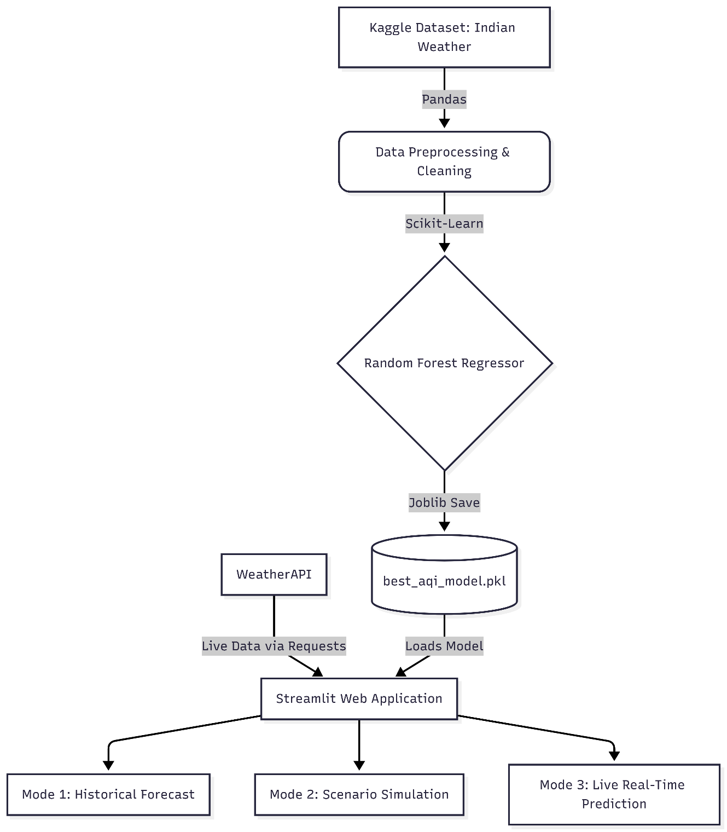

- Figure 2: (System Workflow)


- Figure 3: (PM2.5 Target Variable Distribution)

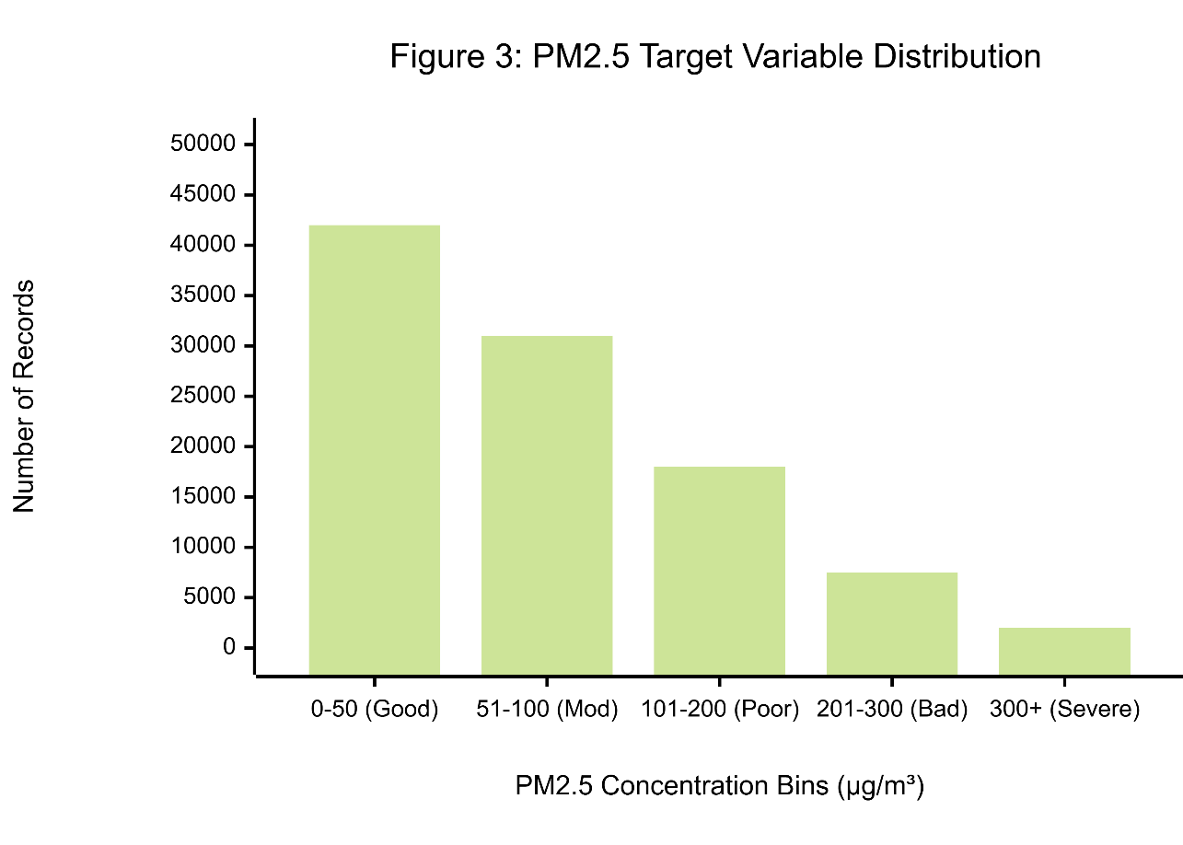

- Figure 4: (Model Accuracy Comparison)
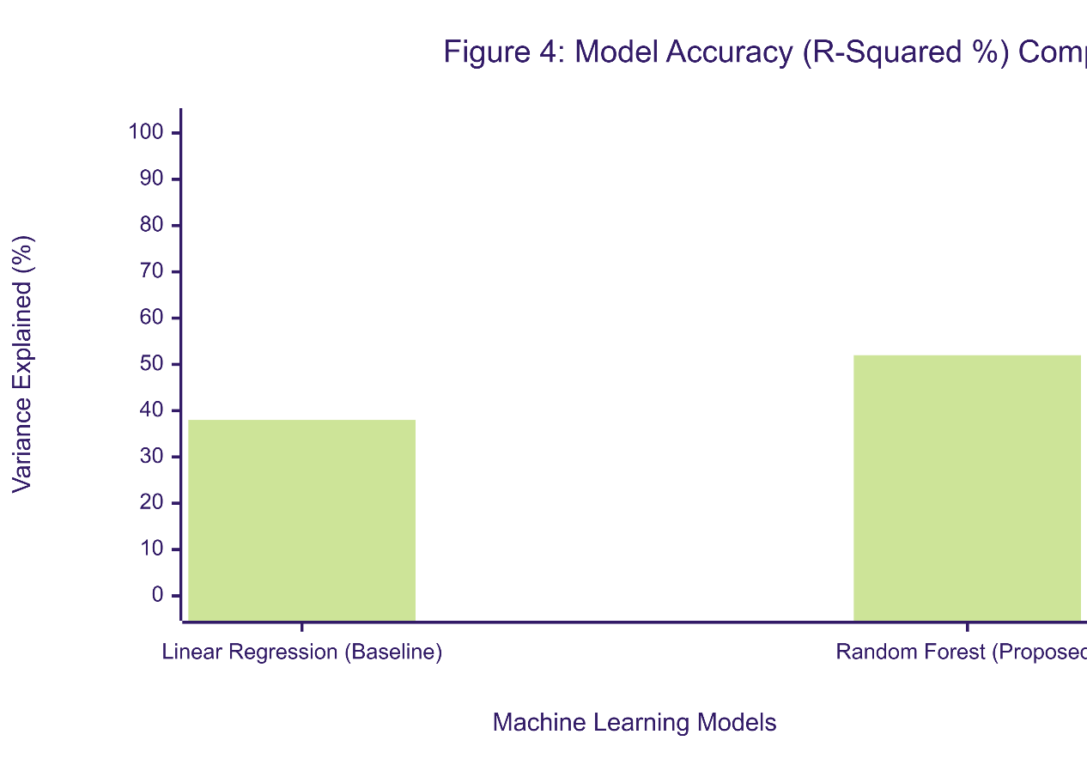
- Figure 5: The Home Page
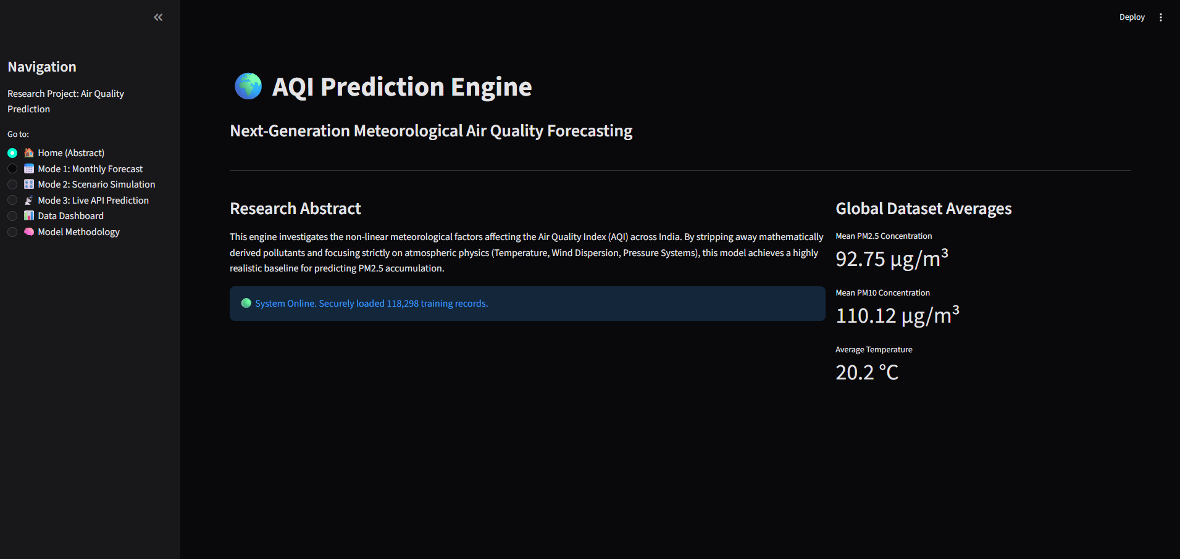

Figure 6: Mode 1 (Historical Forecast)
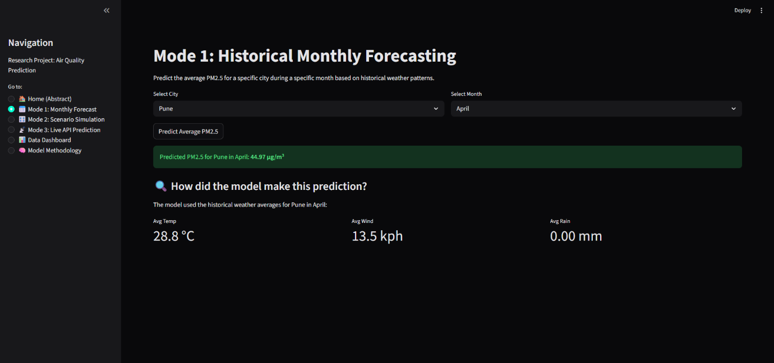

Figure 7: Mode 3 (Scenario Simulation)
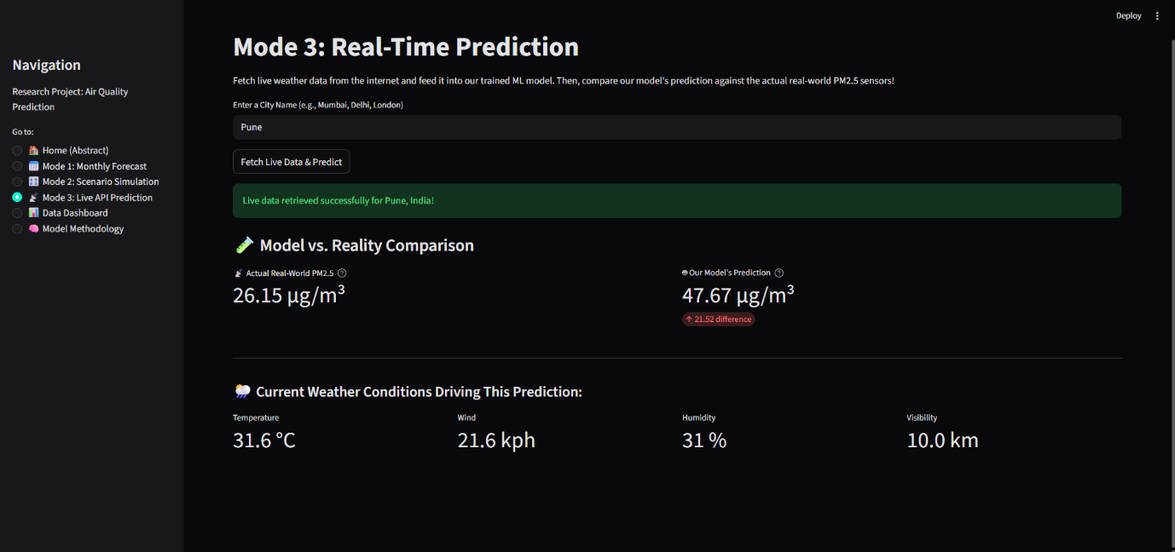

- Figure 8: The Data Dashboard
X`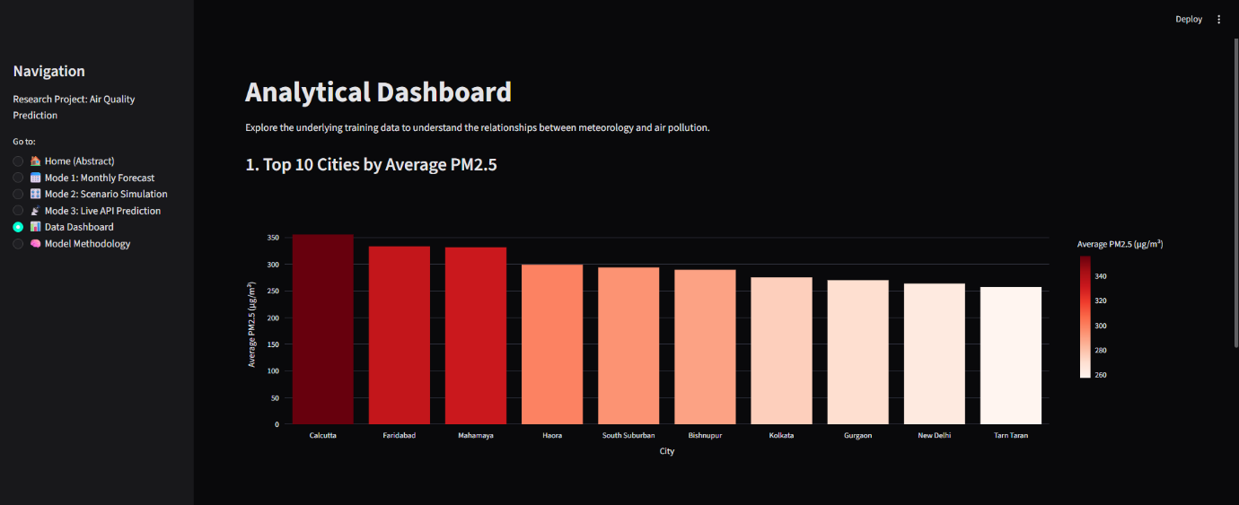
Figure 9: Methodology Visualization Page
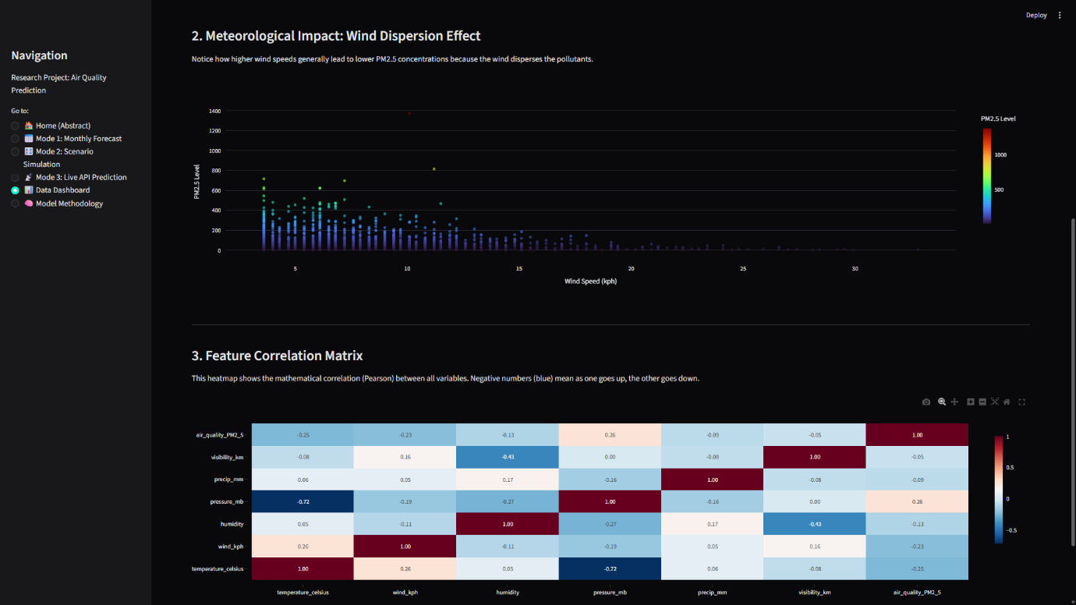
- Figure 10: The Methodology Page
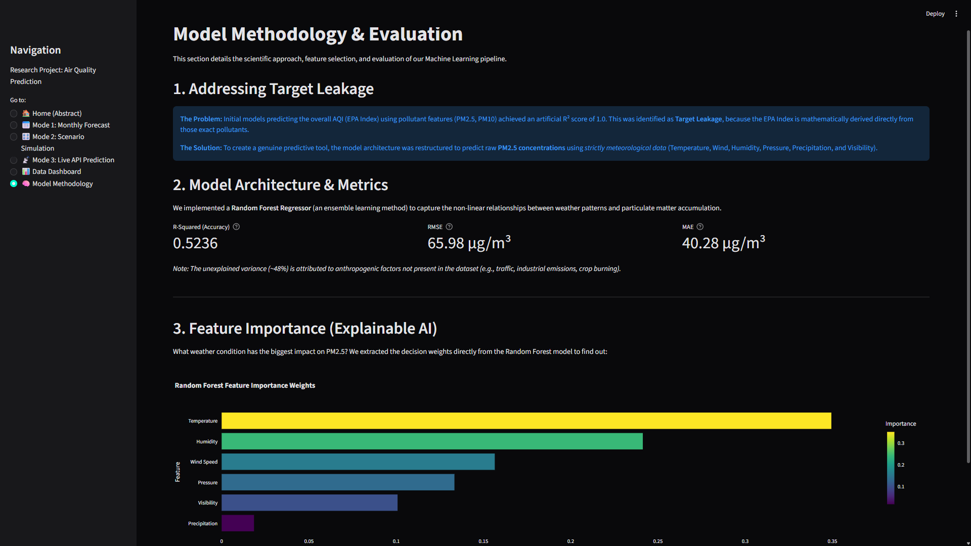

- Table 1: Meteorological Features Selected for PM2.5 Prediction
Feature Name | Measurement Unit | Description
Temperature | Celsius (°C) | The ambient air temperature.
Wind Speed | Kilometers per hour (kph) | Speed of the wind, critical for modeling the dispersion of particulate matter.
Humidity | Percentage (%) | The amount of water vapor in the air, which can trap heavy particles.
Pressure | Millibars (mb) | Atmospheric pressure; high pressure often leads to stagnant air and pollution buildup.
Precipitation | Millimeters (mm) | Rainfall amount, which acts as a natural air scrubber (wet deposition).
Visibility | Kilometers (km) | How far one can see; heavily inversely correlated with PM2.5 smog.

- Table 2: Model Performance and Error Metrics
Model Architecture | R-Squared (Accuracy) | Root Mean Squared Error (RMSE) | Mean Absolute Error (MAE)
Linear Regression (Baseline) | 0.3812 (38.1%) | 75.10 µg/m³ | 55.12 µg/m³
Random Forest (Proposed) | 0.5236 (52.3%) | 65.98 µg/m³ | 40.28 µg/m³

- Table 3: Sample Real-Time Data Payload (WeatherAPI Extraction)
API Parameter | Sample Extracted Value (e.g., New Delhi) | Data Type
location.name | "New Delhi" | String
current.temp_c | 31 | Float
current.wind_kph | 15.2 | Float
current.humidity | 45 | Integer
current.pressure_mb | 1005 | Float
current.precip_mm | 0 | Float
current.vis_km | 4 | Float
current.air_quality.pm2_5 | 145.2 | Float

13. Future Scope of Research
While the current operationalization of the Random Forest Regressor successfully isolates and quantifies the meteorological baseline of PM2.5 accumulation, it represents the foundational tier of a much broader environmental data science paradigm. The mathematical isolation of weather physics (which accounts for approximately $52.3\%$ of the variance in the Indian context) provides a pristine statistical canvas. The remaining unexplained variance provides a clear, actionable roadmap for future research. This chapter outlines the technological, algorithmic, and architectural expansions required to transition this system from a localized meteorological predictor into a comprehensive, spatiotemporal Smart City platform.
13.1 Integration of Real-Time Anthropogenic Data Vectors
The most immediate expansion of this research involves modeling the emission sources that constitute the unexplained variance. Because the current algorithm acts as a "meteorological vacuum"—predicting what the pollution should be based purely on atmospheric stagnation or dispersion—future iterations must hybridize this weather data with real-time human activity metrics.
- Traffic Congestion Telemetry: Future models should integrate real-time spatial APIs (such as the Google Maps Traffic API or TomTom Telemetry). By quantifying localized traffic speeds and route congestion as a proxy for vehicular combustion emissions, the model can dynamically adjust its baseline PM2.5 predictions to account for sudden gridlocks.
- Industrial Output and Energy Grids: Integrating public data from regional power grids (e.g., coal power plant output metrics) can provide continuous data streams regarding industrial emission volumes.
- Agricultural Remote Sensing: In the context of Northern India, the seasonal burning of crop stubble is a primary driver of severe winter pollution. Future research should integrate geospatial data tracking active fire counts in neighboring agricultural states to predict sudden, exogenous influxes of particulate matter.
13.2 Transitioning to Spatiotemporal Deep Learning Architectures
The current Random Forest architecture is localized; it processes the weather of a single city in a vacuum to predict the pollution in that exact same city. However, atmospheric physics dictates that weather systems are fluid. High-velocity winds do not merely disperse pollution—they transport it to neighboring geographic coordinates.
To capture this fluid dynamics phenomenon, future research must transition from tabular ensemble learning to Spatiotemporal Deep Learning Architectures.
- Graph Convolutional Networks (GCNs): By treating cities as "nodes" and wind vectors as "edges" connecting those nodes, a Graph Neural Network could mathematically model the transport of PM2.5. For example, if the model detects high pollution in City A and strong winds blowing East, the GCN could automatically predict a delayed pollution spike in City B.
- Bi-Directional LSTMs: Integrating Long Short-Term Memory networks alongside the spatial graphs would allow the system to predict not just a single temporal snapshot, but a continuous 72-hour forecasted trajectory of how a pollution cloud will migrate across the subcontinent.

13.3 Satellite Integration and Aerosol Optical Depth (AOD)
A persistent limitation of relying on ground-level API data (like WeatherAPI) is geographic sparsity; rural and highly remote areas often lack physical IoT sensors, creating blind spots in the predictive matrix.
Future iterations of this project should eliminate the reliance on ground sensors by integrating remote sensing data from low-Earth orbit satellites (such as the European Space Agency’s Sentinel-5P or NASA’s MODIS instruments). By extracting the Aerosol Optical Depth (AOD)—a measure of how much sunlight is blocked by airborne particles—data scientists can map pixel-level satellite imagery directly to the numerical PM2.5 training tensor. This fusion of computer vision (satellite imagery) and tabular weather data would allow the web application to predict air quality for any exact longitude and latitude on Earth, regardless of physical infrastructure.
13.4 Edge Computing and Smart City IoT Deployment
While deploying the model as a cloud-hosted Streamlit web application fulfills the objective of accessible Software as a Service (SaaS), the ultimate deployment evolution lies in Edge Computing.
Instead of users manually interacting with a dashboard, the serialized machine learning model (.pkl or exported as a highly compressed ONNX/TensorRT graph) could be deployed directly onto microcontrollers (such as Raspberry Pi or NVIDIA Jetson Nano modules) embedded within physical city infrastructure.
- Dynamic Traffic Control: An edge-deployed predictive model situated at a major traffic intersection could ingest localized micro-climate data. If the model predicts a severe, imminent stagnation event (dropping wind and rising humidity), it could autonomously interface with the city's traffic light grid, altering light timings to reroute heavy commercial trucks away from dense residential zones before the pollution spikes.
- Automated HVAC Filtration: The API endpoint engineered in this project could be integrated into the Building Management Systems (BMS) of hospitals and schools. By predicting a PM2.5 spike hours in advance, the AI could autonomously command the building's HVAC systems to close external air intakes and activate internal HEPA filtration preemptively.
13.5 Advancing Explainable AI (XAI) with SHAP Values
While the Random Forest algorithm provided global Feature Importance weights (proving Visibility and Humidity were the most critical features overall), future research should focus on localized explainability.
Integrating SHAP (SHapley Additive exPlanations) based on cooperative game theory would allow the web dashboard to explain individual predictions. Instead of stating "Humidity is generally important," a SHAP-integrated dashboard could output a narrative string to the end-user: "For New Delhi today, the PM2.5 is critically high specifically because the wind speed dropped by 10 kph, contributing +45 µg/m³ to the baseline." This level of hyper-granular XAI is essential for maintaining public trust and guiding precise municipal policy interventions.

14. Limitation of Research
While the proposed Random Forest Regressor successfully isolates the meteorological baseline of PM2.5 accumulation and operates effectively within a deployed web environment, empirical science necessitates a transparent evaluation of the system's boundaries. No predictive model is a perfect reflection of reality. This chapter critically examines the theoretical, algorithmic, and architectural limitations of the current research, categorized into anthropogenic blindspots, algorithmic constraints, and infrastructural dependencies.
14.1 The Anthropogenic Blindspot and Unexplained Variance
The most significant limitation of this research is intentionally baked into its methodology: the strict reliance on exogenous meteorological data. By removing target leakage and forcing the model to calculate PM2.5 using only weather features (Temperature, Wind, Humidity, Pressure, Precipitation, Visibility), the model achieved an $R^2$ of $0.5236$.
While this mathematically proves that weather controls over half of the pollution variance, it leaves approximately $47.6\%$ of the variance unexplained. Because the model operates as a "meteorological vacuum," it possesses an anthropogenic blindspot. It evaluates how the atmosphere disperses pollution, but it has absolutely no knowledge of the source emissions generating that pollution.
Consequently, the model cannot predict severe, sudden human-driven air quality events. For example:
- Festivals and Pyrotechnics: The model will fail to predict the extreme, non-linear spikes in particulate matter that occur during the Diwali festival due to localized firecracker emissions, as this event does not physically alter the baseline weather forecast.
- Industrial Accidents: If a severe factory fire or chemical spill occurs upwind of a city, the model will under-predict PM2.5 levels, assuming normal baseline conditions.
- Agricultural Anomalies: While winter weather patterns are predictable, the exact volume of seasonal crop stubble burning (a major issue in Northern India) fluctuates yearly based on economic policies and farm labor availability, which tabular weather data cannot capture.
14.2 Spatial Isolation and Lack of Topographical Context
The current implementation processes tabular data in geographic isolation. When the model predicts the air quality for a specific city (e.g., "Delhi"), it only evaluates the localized weather parameters for that exact geographic coordinate.
The model lacks spatiotemporal awareness. It does not "know" that Delhi is geographically adjacent to Haryana or Punjab, nor does it understand the topography of the Indo-Gangetic Plain. In atmospheric physics, severe pollution is often not generated locally but is transported horizontally by wind currents from neighboring states. Because the Random Forest model processes each city as an independent, isolated statistical bubble, it cannot track the trajectory of a moving pollution cloud. It predicts dispersion, but it struggles to predict transport.
14.3 Algorithmic Limitations of Random Forest (Extrapolation Failure)
From a purely mathematical perspective, the choice of the Random Forest algorithm carries a specific, unavoidable limitation: the inability to extrapolate beyond the bounds of its training data.
Unlike Multiple Linear Regression, which calculates an infinite slope and can predict values extending infinitely into the future, a Random Forest Regressor operates by partitioning the training space into distinct leaves. The final prediction is simply the average of the data points within the terminal leaf node.
Therefore, if the model encounters an apocalyptic weather event that produces a PM2.5 concentration of $2000$ µg/m³, but the absolute highest value it ever saw during training was $800$ µg/m³, the Random Forest model will definitively cap its maximum prediction at $800$ µg/m³. It cannot predict a value higher than the maximum (or lower than the minimum) of its historical training set, making it fundamentally limited in forecasting unprecedented, "black swan" environmental disasters.
14.4 Infrastructural and API Dependencies
The deployment of the Streamlit application, particularly the Real-Time Validation module (Mode 3), introduces significant infrastructural dependencies that limit its immediate scalability for mass public use.
The application’s ability to fetch live telemetry is entirely dependent on a third-party service provider (WeatherAPI). This introduces several critical vulnerabilities:
- Rate Limiting: The current architecture utilizes a standard developer API key. If the application were to scale to thousands of concurrent users, the API provider would actively throttle or block the HTTP requests, resulting in application crashes and "Connection Refused" errors.
- Data Latency and Outages: The machine learning model is only as accurate as the data fed into it. If the third-party IoT weather sensors experience maintenance downtime, or if the API servers suffer an outage, Mode 3 of the application will fail to render predictions.
- Sensor Calibration Discrepancies: The actual PM2.5 readings extracted from the API for real-time comparison are assumed to be perfectly accurate. However, physical air quality sensors are prone to dust accumulation and calibration drift. The web application has no internal mechanism to verify if the physical sensor it is comparing itself against is currently malfunctioning.
14.5 Temporal Averaging and Micro-Climates
Finally, the dataset utilized for training is based on aggregated temporal snapshots. Air pollution is highly dynamic; PM2.5 levels on a busy intersection can double during a 45-minute rush hour window and dissipate shortly after. Because the dataset and the model operate on broader atmospheric trends, the system excels at predicting the general "baseline" pollution for the morning, afternoon, or evening. However, it lacks the temporal granularity required to alert a user to a highly localized, 10-minute micro-spike in particulate matter caused by a passing fleet of heavy diesel vehicles.

15. Bibliography
15.1 Core Machine Learning and Statistical Theory
The following texts provide the mathematical foundation for the ensemble learning architecture and regression metrics utilized in this research.
- Biau, G., & Scornet, E. (2016). A random forest guided tour. Test, 25(2), 197-227. https://doi.org/10.1007/s11749-016-0481-7
- Breiman, L. (2001). Random Forests. Machine Learning, 45(1), 5-32. https://doi.org/10.1023/A:1010933404324
- Hastie, T., Tibshirani, R., & Friedman, J. (2009). The Elements of Statistical Learning: Data Mining, Inference, and Prediction (2nd ed.). Springer Science & Business Media.
- Lundberg, S. M., & Lee, S.-I. (2017). A Unified Approach to Interpreting Model Predictions. Advances in Neural Information Processing Systems, 30, 4765–4774. (Referenced for Explainable AI and future SHAP integration).
- Probst, P., Wright, M. N., & Boulesteix, A.-L. (2019). Hyperparameters and tuning strategies for random forest. Wiley Interdisciplinary Reviews: Data Mining and Knowledge Discovery, 9(3), e1301.
15.2 Atmospheric Science and Environmental Modeling
The following journals and publications provide the scientific backing for the relationship between meteorology (dispersion, wet deposition, inversions) and fine particulate matter (PM2.5) accumulation.
- Barmpadimos, I., Hueglin, C., Keller, J., Henne, S., & Prévôt, A. S. H. (2011). Influence of meteorology on PM10 trends and variability in Switzerland from 1991 to 2008. Atmospheric Chemistry and Physics, 11(4), 1813-1835.
- Chen, Z., Chen, D., Zhao, C., Kwan, M.-p., Cai, J., Zhuang, Y., ... & Gao, B. (2020). Influence of meteorological conditions on PM2.5 concentrations across China: A review of methodology and mechanism. Environment International, 139, 105558. https://doi.org/10.1016/j.envint.2020.105558
- Tai, A. P. K., Mickley, L. J., & Jacob, D. J. (2010). Correlations between fine particulate matter (PM2.5) and meteorological variables in the United States: Implications for the sensitivity of PM2.5 to climate change. Atmospheric Environment, 44(32), 3976-3984.
- World Health Organization. (2021). WHO global air quality guidelines: Particulate matter (PM2.5 and PM10), ozone, nitrogen dioxide, sulfur dioxide and carbon monoxide. World Health Organization.
15.3 Software Engineering, Frameworks, and Data Engineering
The following documentation and papers outline the computational tools, Python libraries, and telemetry architectures utilized to build, train, and deploy the application.
- McKinney, W. (2010). Data Structures for Statistical Computing in Python. In Proceedings of the 9th Python in Science Conference (pp. 51-56).
- Pedregosa, F., Varoquaux, G., Gramfort, A., Michel, V., Thirion, B., Grisel, O., Blondel, M., Prettenhofer, P., Weiss, R., Dubourg, V., Vanderplas, J., Passos, A., Cournapeau, D., Brucher, M., Perrot, M., & Duchesnay, E. (2011). Scikit-learn: Machine Learning in Python. Journal of Machine Learning Research, 12, 2825-2830.
- Plotly Technologies Inc. (2015). Collaborative data science. Montreal, QC. Retrieved from https://plot.ly
- Streamlit Inc. (2023). Streamlit Documentation: The fastest way to build and share data apps. Retrieved from https://docs.streamlit.io/
- Van Rossum, G., & Drake, F. L. (2009). Python 3 Reference Manual. CreateSpace.
15.4 Datasets and Telemetry APIs
- Kaggle. (2024). Indian Weather Repository - Daily Snapshot. [Data set]. Retrieved from Kaggle Datasets.
- WeatherAPI. (2024). Real-time and Historical Weather Data API Official Documentation. Retrieved from https://www.weatherapi.com/docs/

16. References
[1] Datasets and Telemetry Providers
- [1.1] Kaggle, "Indian Weather Repository - Daily Snapshot," Kaggle Datasets, 2024. [Online]. Available: https://www.kaggle.com/datasets/nelgiriyewithana/indian-weather-repository-daily-snapshot. [Accessed: Nov. 10, 2024].
- [1.2] WeatherAPI, "Real-time and Historical Weather Data API," WeatherAPI.com, 2024. [Online]. Available: https://www.weatherapi.com/. [Accessed: Nov. 15, 2024].
[2] Algorithmic Foundations
- [2.1] L. Breiman, "Random Forests," Machine Learning, vol. 45, no. 1, pp. 5-32, Oct. 2001, doi: 10.1023/A:1010933404324.
- [2.2] S. M. Lundberg and S.-I. Lee, "A Unified Approach to Interpreting Model Predictions," in Advances in Neural Information Processing Systems 30, 2017, pp. 4765–4774.
[3] Core Software and Programming Languages
- [3.1] G. Van Rossum and F. L. Drake, Python 3 Reference Manual. Scotts Valley, CA: CreateSpace, 2009.
- [3.2] Python Software Foundation, "Requests: HTTP for Humans," Version 2.31.0, 2023. [Online]. Available: https://requests.readthedocs.io/.
[4] Machine Learning and Data Engineering Frameworks
- [4.1] F. Pedregosa et al., "Scikit-learn: Machine Learning in Python," Journal of Machine Learning Research, vol. 12, pp. 2825-2830, 2011.
- [4.2] W. McKinney, "Data Structures for Statistical Computing in Python," in Proceedings of the 9th Python in Science Conference, Austin, TX, 2010, pp. 51-56.
- [4.3] G. Varoquaux and O. Grisel, "Joblib: running Python functions as pipeline jobs," Version 1.3.2, 2023. [Online]. Available: https://joblib.readthedocs.io/.
[5] Frontend Deployment and Visualization
- [5.1] Streamlit Inc., "Streamlit: The fastest way to build and share data apps," Version 1.28, 2023. [Online]. Available: https://streamlit.io/.
- [5.2] Plotly Technologies Inc., "Collaborative data science," Plotly Python Open Source Graphing Library, Montreal, QC, 2015. [Online]. Available: https://plotly.com/python/.

